SAVITRIBAI PHULE PUNE UNIVERSITY

A PROJECT REPORT ON

BMI AND DIET

BY

SURAJ SHINDE ( T150884321)

SHUBHAM GOUR (T150884326)

SWAPNIL WADGAVE(T150884343)

SIDHARAM YALASANGI(T150884345)

Under The Guidance of

Prof.ASHWINI NAVALE



DEPARTMENT OF COMPUTER ENGINEERING

Dr. D. Y. PATIL SCHOOL OF ENGINEERING

Dr. D. Y. PATIL TECHNICAL CAMPUS

PUNE-412 105



Dr. D. Y. PATIL SCHOOL OF ENGINEERING, PUNE

DEPARTMENT OF COMPUTER ENGINEERING

CERTIFICATE

This is to certify that the Project Entitled

**BMI AND DIET**

Submitted by

SURAJ SHINDE ( T150884321)

SHUBHAM GOUR (T150884326)

SWAPNIL WADGAVE(T150884343)

SIDHARAM YALASANGI(T150884345)

is a bonafide work carried out by students under the supervision of Prof. ASHWINI NAVALE and it is submitted towards the fulfillment of the requirement of Skill Development Lab Mini Project.

|  |  |
| --- | --- |
| Prof.ASHWINI NAVALE | Prof. S. S. Das |
| Internal Guide | H.O.D |
| Dept. of Computer Engg. | Dept. of Computer Engg. |

INDEX

|  |  |  |
| --- | --- | --- |
| **SR. NO** | **CONTENTS** | |
| 1 | Abstract ……………………………………………………………………………….. | |
| 2 | Introduction………………………………………………………………… | |
| 2.1 | Project Idea………………………………………………………… |
| 2.2 | Motivation and Scope of the Project ………………………………. |
| 3 | Requirement Analysis…………………………………………………….. | |
| 3.1 | Hardware Requirement……………………………………………… |
| 3.2 | Software Requirement………………………………………………. |
| 4 | System Design……………………………………………………………. | |
| 4.1 | System Architecture………………………………………………. |
| 4.2 | Flow of System……………………………………………………. |
| 4.3 | Entity Relationship Model, Relational Model, Database Normalization |
| 5 | Implementation……………………………………………………………. | |
| 5.1 | Source Code…………………………………………………… |
| 5.2 | System Output (GUI Output)……………………………………… |
| 6 | Testing Document…………………………………………………………………… | |
| 7 | Conclusion …………………………………………………………………. | |

Abstract

The dietician is an application about human diets. It acts as a diet consultant similar to a real dietician. This system acts in a similar way as that of a dietician. A person in order to know its diet plan needs to give some information to the dietician such as its body type, weight, height and its working hour details. Similar way this system also provides the diet plan according to the information entered by the user. The system asks all this data from the user and processes it to provide the diet plan to the user. Thus the user does not need to visit any dietician which also saves time and the user can get the required diet plan in just a click. The system will give more accurate results as it accepts the data entered by the user and processes it depending on some metrics already known to the application on the basis of which a diet plan is generated and ask the user if the user accepts the diet plan. If not accepted the system may also give and alternative diet plan. Just similar to a human dietician, this system based on android operating system will also act like your device dietician. When you go to a doctor of nutrition, than she will ask you your personal details related to body and health such as your age, your height, your weight and how much water do you consumer in a day and how much walk to do take regularly and how much work do you do regularly. this App will also advice you about what should you intake in your diet and what should you ignore in order to keep yourself healthy via your diet.

2. INTRODUCTION

2.1Project idea

Just similar to a human dietician, this system based on android operating system will also act like your device dietician. When you go to a doctor of nutrition, than she will ask you your personal details related to body and health such as your age, your height, your weight and how much water do you consumer in a day and how much walk to do take regularly and how much work do you do regularly. Just similar to this doctor, this artificial intelligent diet consultant also ask you similar questions in your device and you have to answer all those questions and then this AI consultant will also advice you about what should you intake in your diet and what should you ignore in order to keep yourself healthy via your diet.

In this proposed system of android artificial intelligence diet consultant, using the technique of artificial intelligence, you will get access to all the facilities via this application, which is actually provided by a human dietician. The main advantage of using this standalone application is that the time required by the people to travel to the dietician will be reduced and also it reduces the cost of hiring dieticians for some particular purpose.

Also, this application offers more than one diet plan also, for some particular kind of functionalities of human bodies.

2.2 Motivation and Scope of the Project

In the existing system, you have to hire a dietician in order to get advice. Hiring a nutrition doctor will not only waste your time and efforts for calling them, going to them and so on but also cost you very high as their charges per month are very high. The moment will also arrives when they will not available for you and you have to search for some other dietician urgently. So we are develop android application

2.2.1 Objective: The objective of this project is to suggests diet plan based on user’s height, weight and eating habits.

The system measures a user’s body mass index using his/her height and weight. The system has been trained with large dataset of food varieties and their nutritional values. Once the system has the user’s body mass index, it needs to know eating habit of the user. The user has to provide information about the timings he eats. Timings for breakfast, lunch, snacks and dinner are entered by the user. Once the system has this data, it suggests the user a diet plan as per the user’s body mass index. If the user doesn’t like the diet plan the system modifies the diet plan keeping nutritional value the same. This is done to ensure that the user likes the diet suggested to him. Thus the need to travel to a dietician to know the diet plan can be removed. The users can get a diet plan based on their body mass index if they know their height and weight. No need to pay a visit to local dietician any more.

Requirement Analysis

Hardware Requirement

* Processor: i3 or above
* RAM: 4 GB or above
* Android device

Software Requirement

* Windows 7 or above
* JDK
* ANDROID STUDIO
* SDK
* SQLite

3.**SYSTEM DESIGN**

3.1 SYSTEM ARCHITECTURE

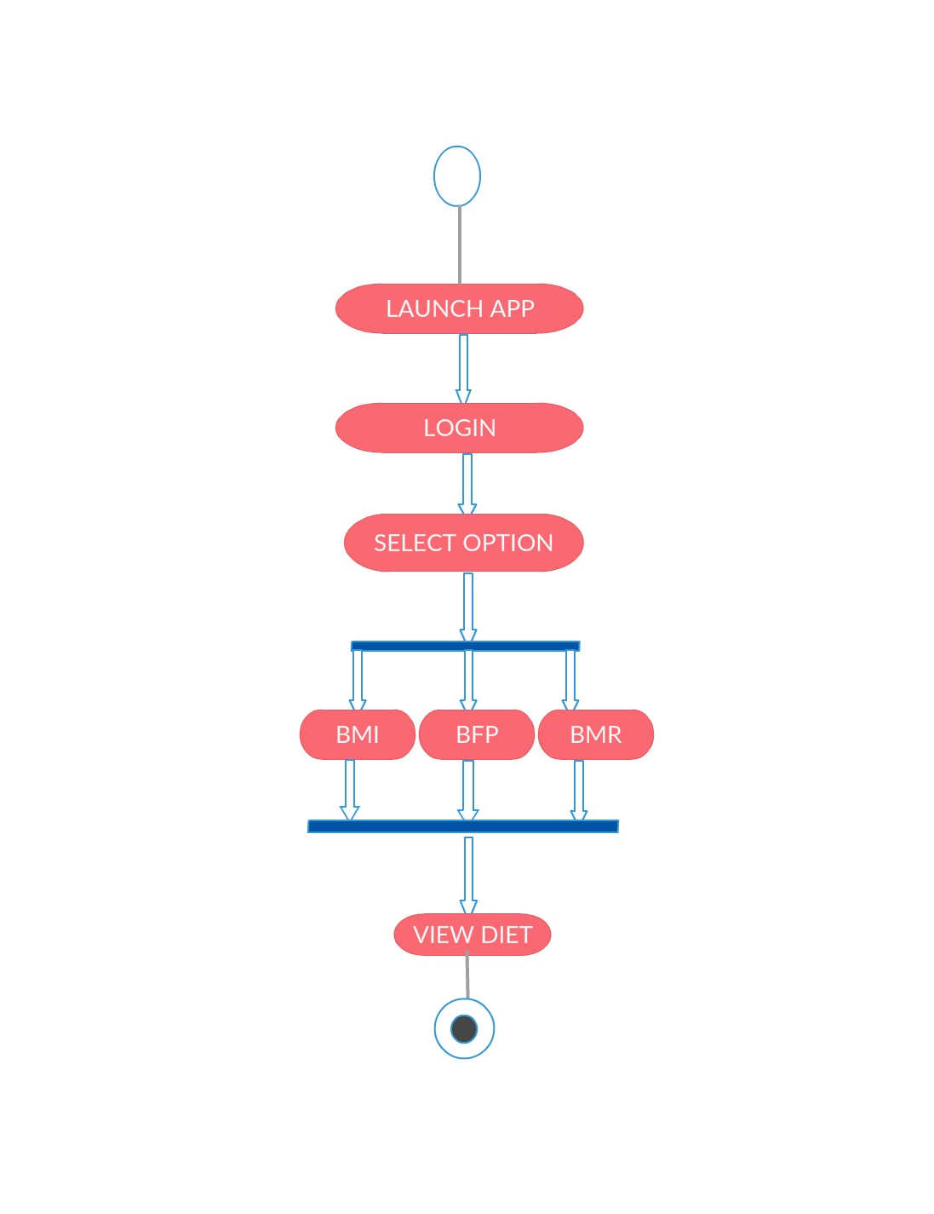

3.2 ENTITY RELATIONSHIP DIAGRAM

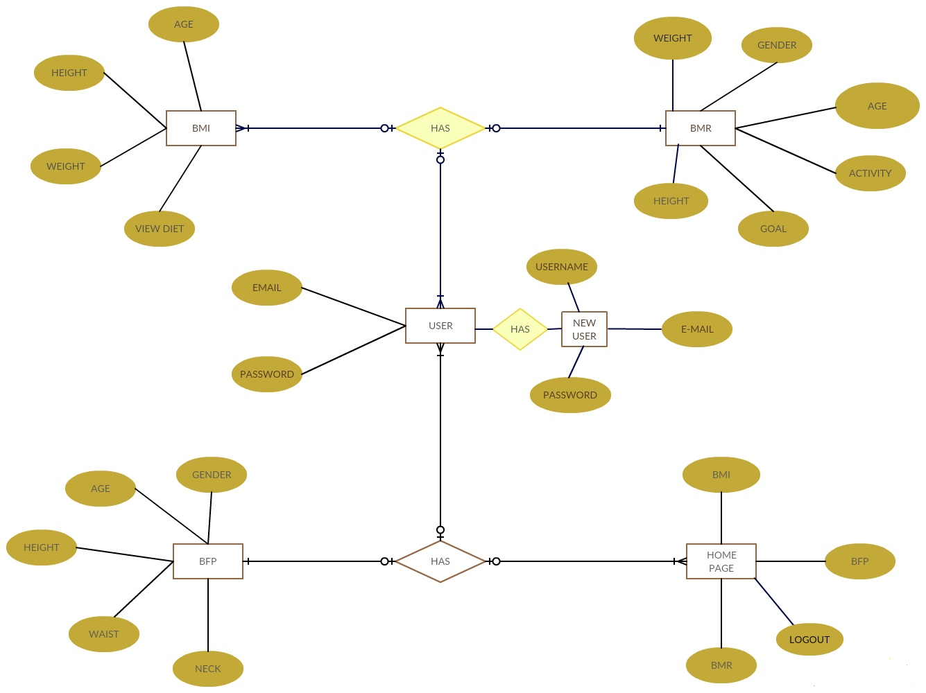

3.3 NORMALISATION

A database is in third normal form if it satisfies the following conditions:

* It is in second normal form
* There is no transitive functional dependency

**4. IMPLEMENTATION**

4.1 SOURCE CODE

BMI

**package** com.test.bmi;  
  
**import** android.os.Build;  
**import** android.os.Bundle;  
**import** android.support.annotation.Nullable;  
**import** android.support.annotation.RequiresApi;  
**import** android.support.v7.app.AppCompatActivity;  
**import** android.widget.ImageView;  
  
**public class** ScrDiet **extends** AppCompatActivity {  
 @RequiresApi(api = Build.VERSION_CODES.***JELLY_BEAN***)  
 @Override  
 **protected void** onCreate(@Nullable Bundle savedInstanceState) {  
 **super**.onCreate(savedInstanceState);  
 setContentView(R.layout.***scr_diet***);  
 ImageView ivDiet = findViewById(R.id.***iv_diet***);  
 **if** (BMIApp.*bmi* < 16) {  
 ivDiet.setBackground(getResources().getDrawable(R.drawable.***very_low***));  
 } **else if** (BMIApp.*bmi* > 16 && BMIApp.*bmi* < 18.5) {  
 ivDiet.setBackground(getResources().getDrawable(R.drawable.***low***));  
 } **else if** (BMIApp.*bmi* > 18.5 && (BMIApp.*bmi* <= 25)) {  
 ivDiet.setBackground(getResources().getDrawable(R.drawable.***normal***));  
 } **else if** (BMIApp.*bmi* > 25) {  
 ivDiet.setBackground(getResources().getDrawable(R.drawable.***obesity***));  
 }  
 }  
}

BASAL METABOLIC RATE ( BMR )

**public void** calculate() {  
 **float** getHeight = 0f, getWeight, getage;  
 DecimalFormat df = **new** DecimalFormat(**"#0.0"**);  
  
 **if** (**height_ft**.isShown() && **height_in**.isShown()) {  
 **if** (**height_ft**.getText().toString().equals(**""**) && **height_in**.getText().toString().equals(**""**))  
 getHeight = 0f;  
 **if** (**height_ft**.getText().toString().equals(**""**) && !**height_in**.getText().toString().equals(**""**))  
 getHeight = Float.*parseFloat*(**height_in**.getText().toString());  
 **if** (**height_in**.getText().toString().equals(**""**) && !**height_ft**.getText().toString().equals(**""**))  
 getHeight = Float.*parseFloat*(**height_ft**.getText().toString()) * 12f;  
 **if** (!**height_ft**.getText().toString().equals(**""**) && !**height_in**.getText().toString().equals(**""**))  
 getHeight = Float.*parseFloat*(**height_ft**.getText().toString()) * 12f + Float.*parseFloat*(**height_in**.getText().toString());  
 }  
 **if** (**height_cm**.isShown()) {  
 **if** (**height_cm**.getText().toString().equals(**""**))  
 getHeight = 0f;  
 **else** getHeight = Float.*parseFloat*(**height_cm**.getText().toString());  
 }  
  
 **if** (**weight**.getText().toString().equals(**""**)) {  
 getWeight = 0f;  
 } **else** {  
 getWeight = Float.*parseFloat*(**weight**.getText().toString());  
 }  
 **if** (**age**.getText().toString().equals(**""**)) {  
 getage = 0f;  
 } **else** {  
 getage = Float.*parseFloat*(**age**.getText().toString());  
 }  
  
 **if** (getHeight != 0f && getWeight != 0f && getage != 0f) {  
  
 **if** (**sex_selected**.equals(**"Male"**)) {  
 **if** (**selected_item1**.equals(**"ft + in"**)) {  
 **if** (**selected_item2**.equals(**"lb"**)) {  
 **bmr** = 10 * getWeight * 0.453592f + 6.25f * getHeight * 2.54f - 5 * getage + 5;  
 }  
 **if** (**selected_item2**.equals(**"kg"**)) {  
 **bmr** = 10 * getWeight + 6.25f * getHeight * 2.54f - 5 * getage + 5;  
 }  
 }  
  
 **if** (**selected_item1**.equals(**"cm"**)) {  
 **if** (**selected_item2**.equals(**"lb"**)) {  
 **bmr** = 10 * getWeight * 0.453592f + 6.25f * getHeight - 5 * getage + 5;  
 }  
 **if** (**selected_item2**.equals(**"kg"**)) {  
 **bmr** = 10 * getWeight + 6.25f * getHeight - 5 * getage + 5;  
 }  
 }  
 }  
  
 **if** (**sex_selected**.equals(**"Female"**)) {  
 **if** (**selected_item1**.equals(**"ft + in"**)) {  
 **if** (**selected_item2**.equals(**"lb"**)) {  
 **bmr** = 10 * getWeight * 0.453592f + 6.25f * getHeight * 2.54f - 5 * getage - 161;  
 }  
 **if** (**selected_item2**.equals(**"kg"**)) {  
 **bmr** = 10 * getWeight + 6.25f * getHeight * 2.54f - 5 * getage - 161;  
 }  
 }  
  
 **if** (**selected_item1**.equals(**"cm"**)) {  
 **if** (**selected_item2**.equals(**"lb"**)) {  
 **bmr** = 10 * getWeight * 0.453592f + 6.25f * getHeight - 5 * getage - 161;  
 }  
 **if** (**selected_item2**.equals(**"kg"**)) {  
 **bmr** = 10 * getWeight + 6.25f * getHeight - 5 * getage - 161;  
 }  
 }  
 }

BODY FAT PERCENTAGE ( BFP )

**if** (**age**.getText().toString().equals(**""**) || (**age**.getText().toString().length() >= 1 && **age**.getText().toString().length() <= 6)  
 || bfp == -1f || bfp == 0f) {  
 **mChart**.highlightValue(0, -1, **false**);  
  
}  
**if** (**age**.getText().toString().length() != 0) {  
 **if** (Integer.*parseInt*(**age**.getText().toString()) == 7) {  
 **if** (**sex_selected**.equals(**"Male"**)) {  
 **if** (**fatpercent** <= 14.9f && **fatpercent** > 0f) {  
 **mChart**.highlightValue(0, 0, **false**);  
 **l1**.setBackgroundColor(Color.*rgb*(220, 220, 220));  
 }  
 **if** (**fatpercent** <= 24.9f && **fatpercent** >= 15.0f) {  
 **mChart**.highlightValue(1, 0, **false**);  
 **l2**.setBackgroundColor(Color.*rgb*(220, 220, 220));  
 }  
 **if** (**fatpercent** >= 25f && **fatpercent** <= 28.9f) {  
 **mChart**.highlightValue(2, 0, **false**);  
 **l3**.setBackgroundColor(Color.*rgb*(220, 220, 220));  
 }  
 **if** (**fatpercent** >= 29f) {  
 **mChart**.highlightValue(3, 0, **false**);  
 **l4**.setBackgroundColor(Color.*rgb*(220, 220, 220));  
 }  
  
 }  
 **if** (**sex_selected**.equals(**"Female"**)) {  
 **if** (**fatpercent** > 0f && **fatpercent** <= 12.9f) {  
 **mChart**.highlightValue(0, 0, **false**);  
 **l1**.setBackgroundColor(Color.*rgb*(220, 220, 220));  
 }  
 **if** (**fatpercent** >= 13.0f && **fatpercent** <= 19.9f) {  
 **mChart**.highlightValue(1, 0, **false**);  
 **l2**.setBackgroundColor(Color.*rgb*(220, 220, 220));  
 }  
 **if** (**fatpercent** >= 20.0f && **fatpercent** <= 24.9f) {  
 **mChart**.highlightValue(2, 0, **false**);  
 **l3**.setBackgroundColor(Color.*rgb*(220, 220, 220));  
 }  
 **if** (**fatpercent** >= 25.0f) {  
 **mChart**.highlightValue(3, 0, **false**);  
 **l4**.setBackgroundColor(Color.*rgb*(220, 220, 220));  
 }  
  
 }  
  
 }

4.2 GRAPHIC USER INTERFACE ( GUI ) 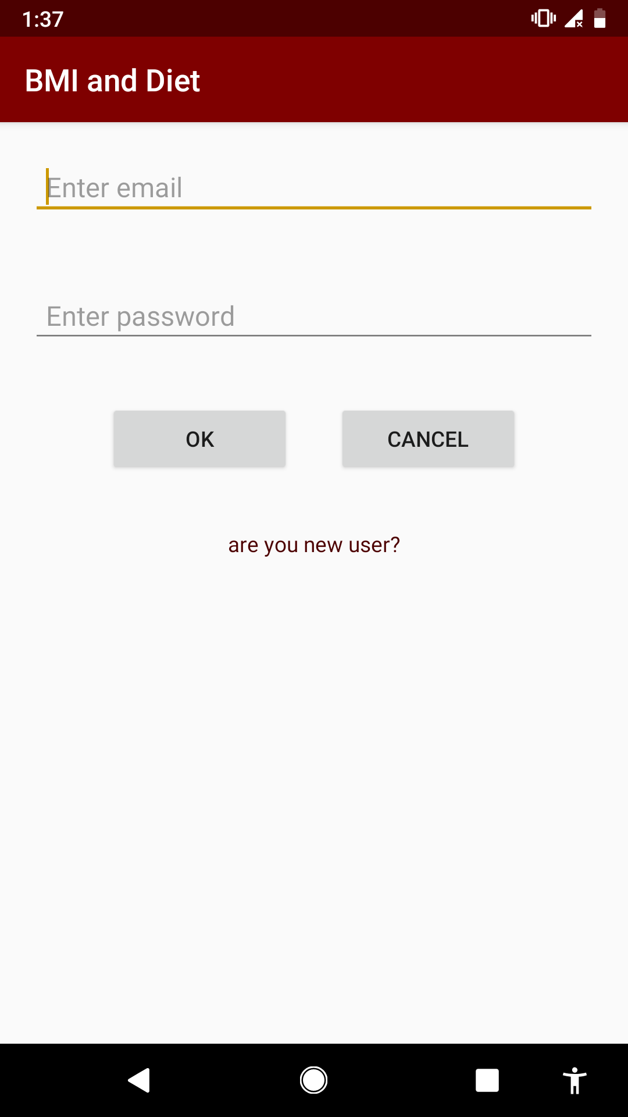

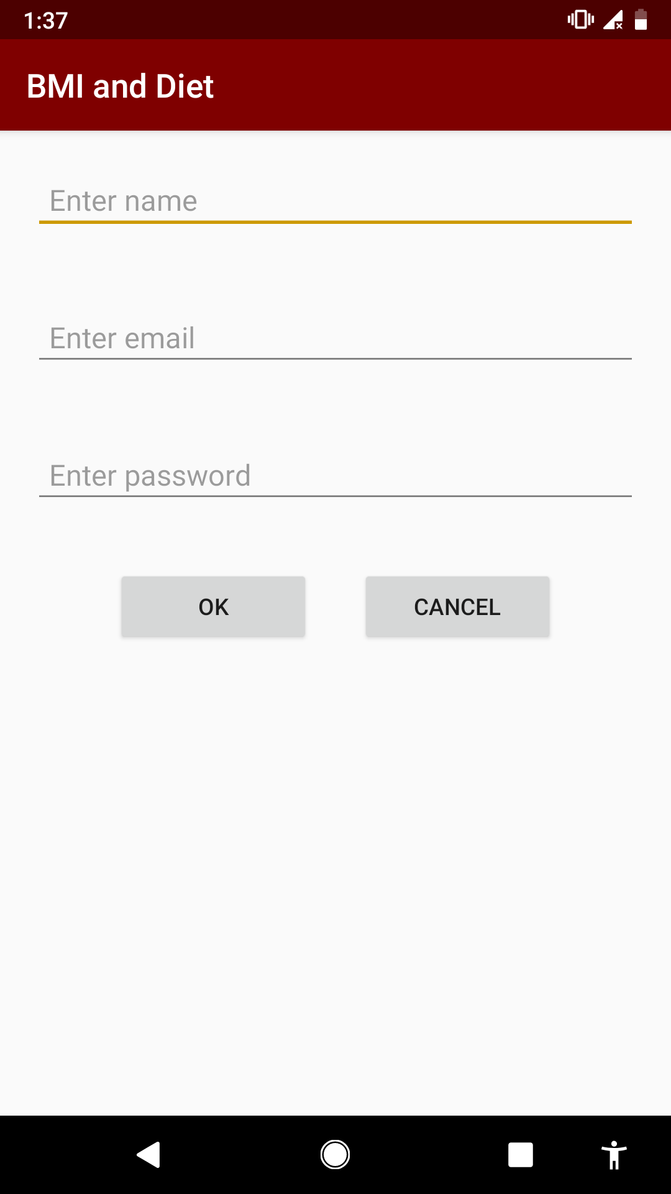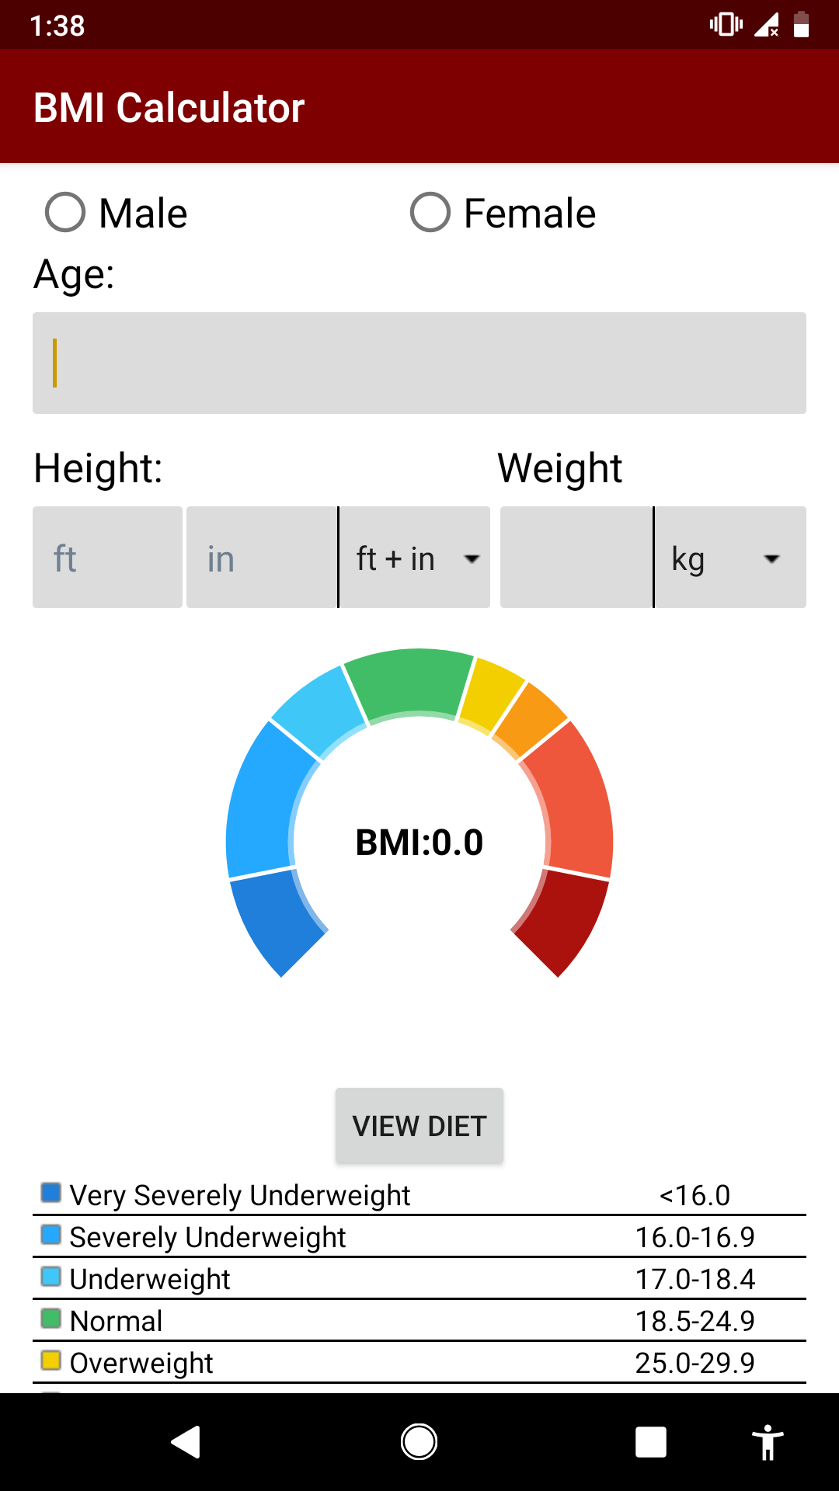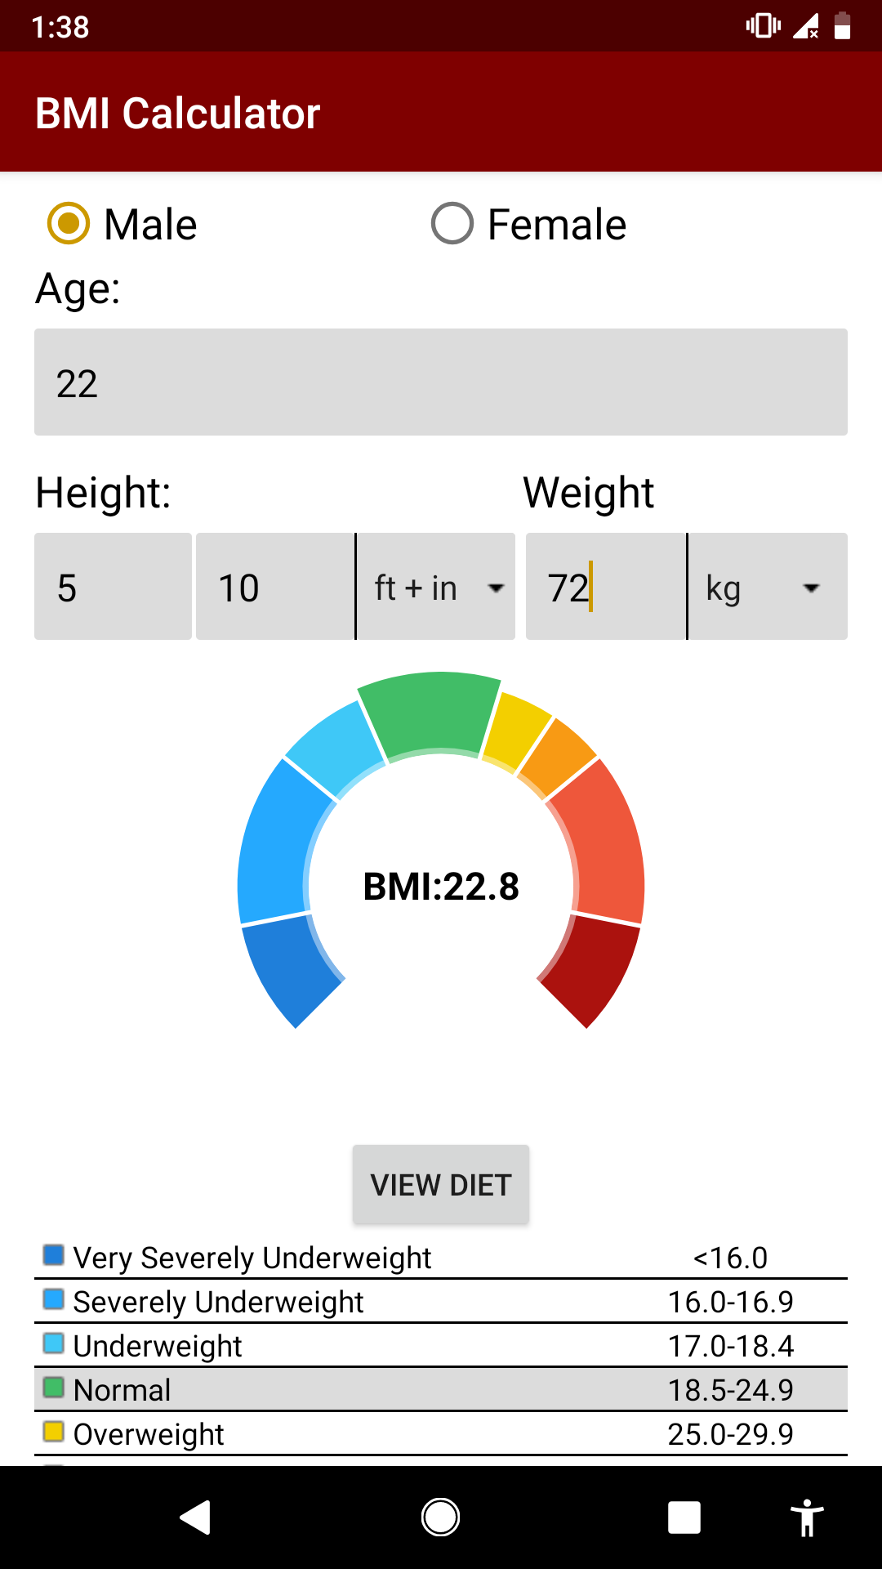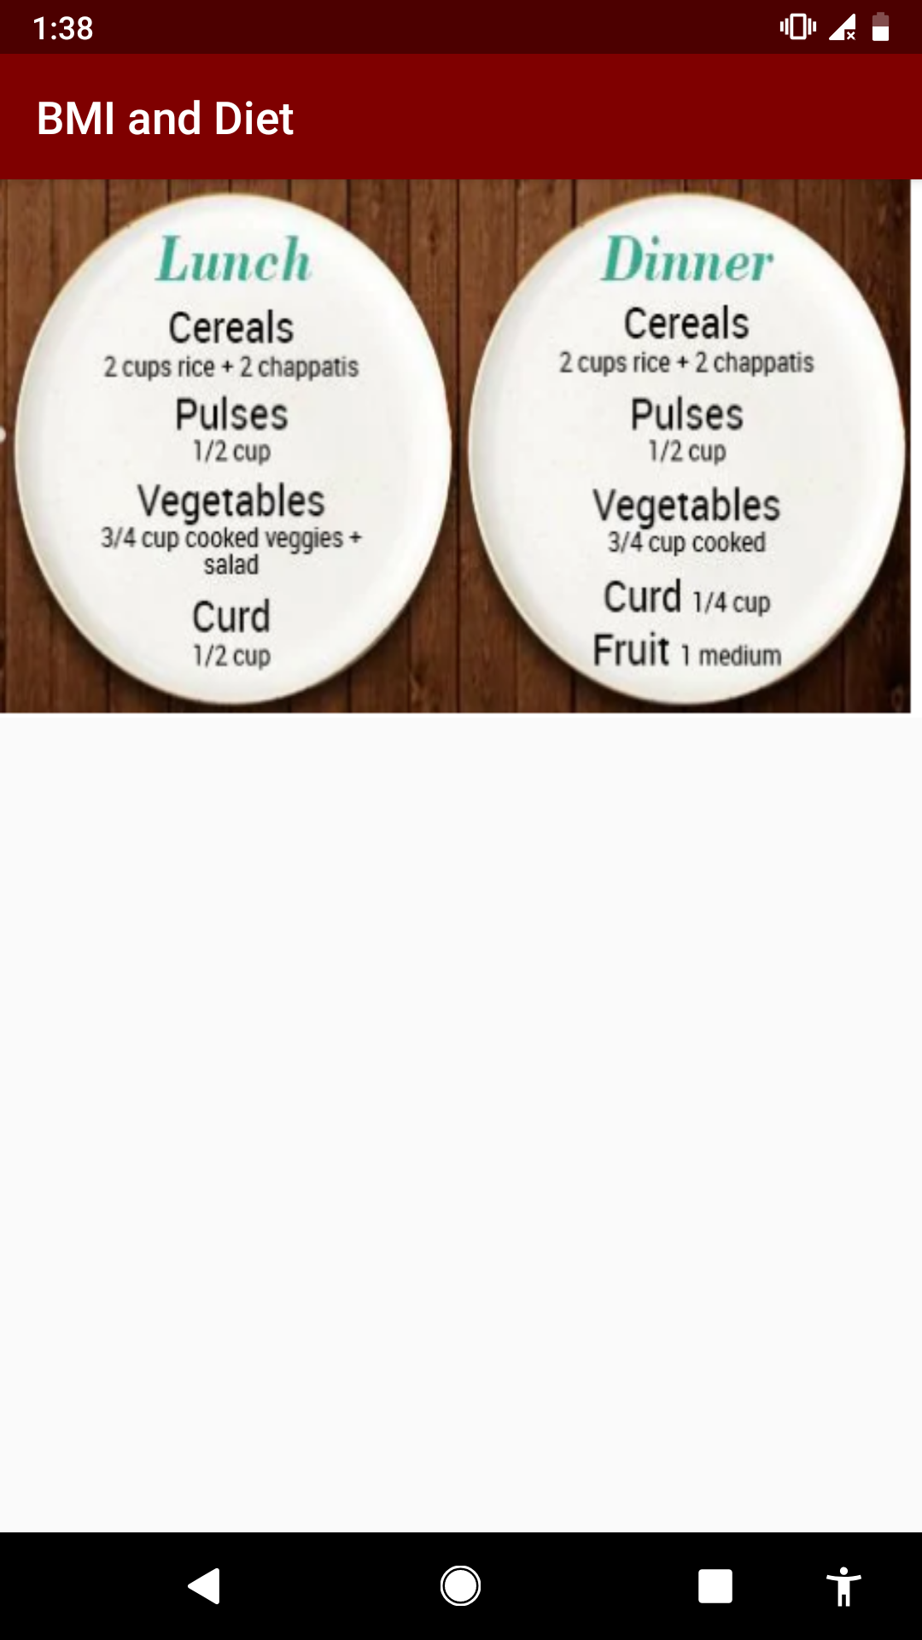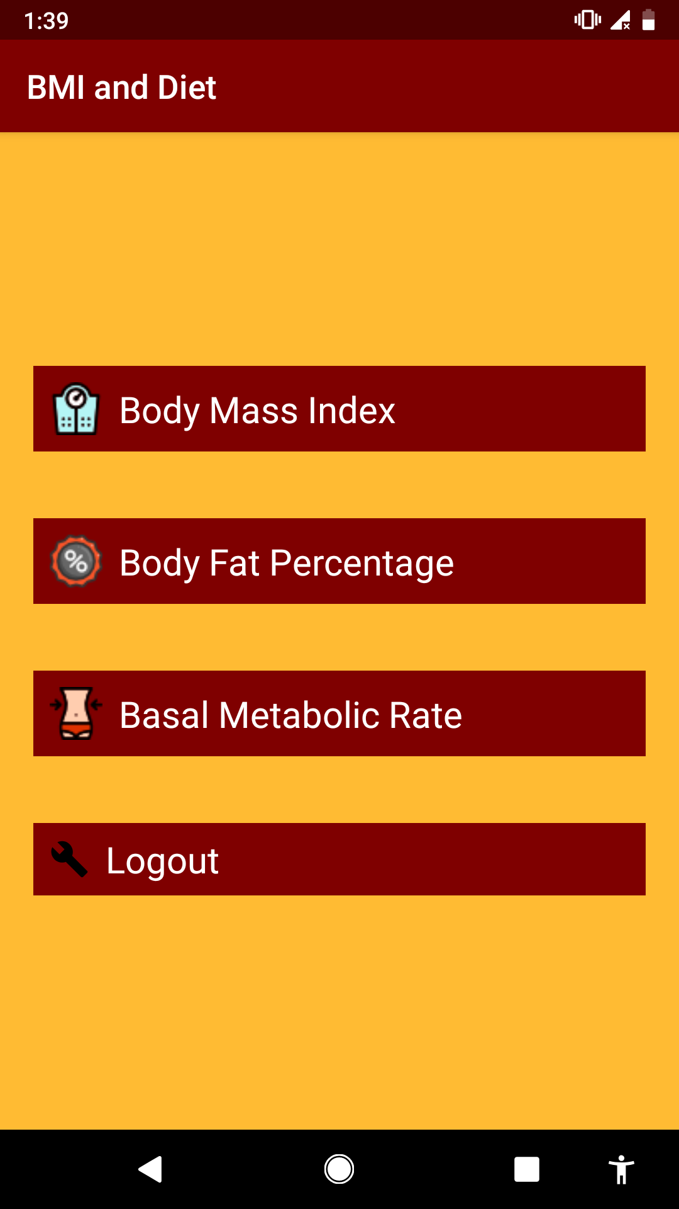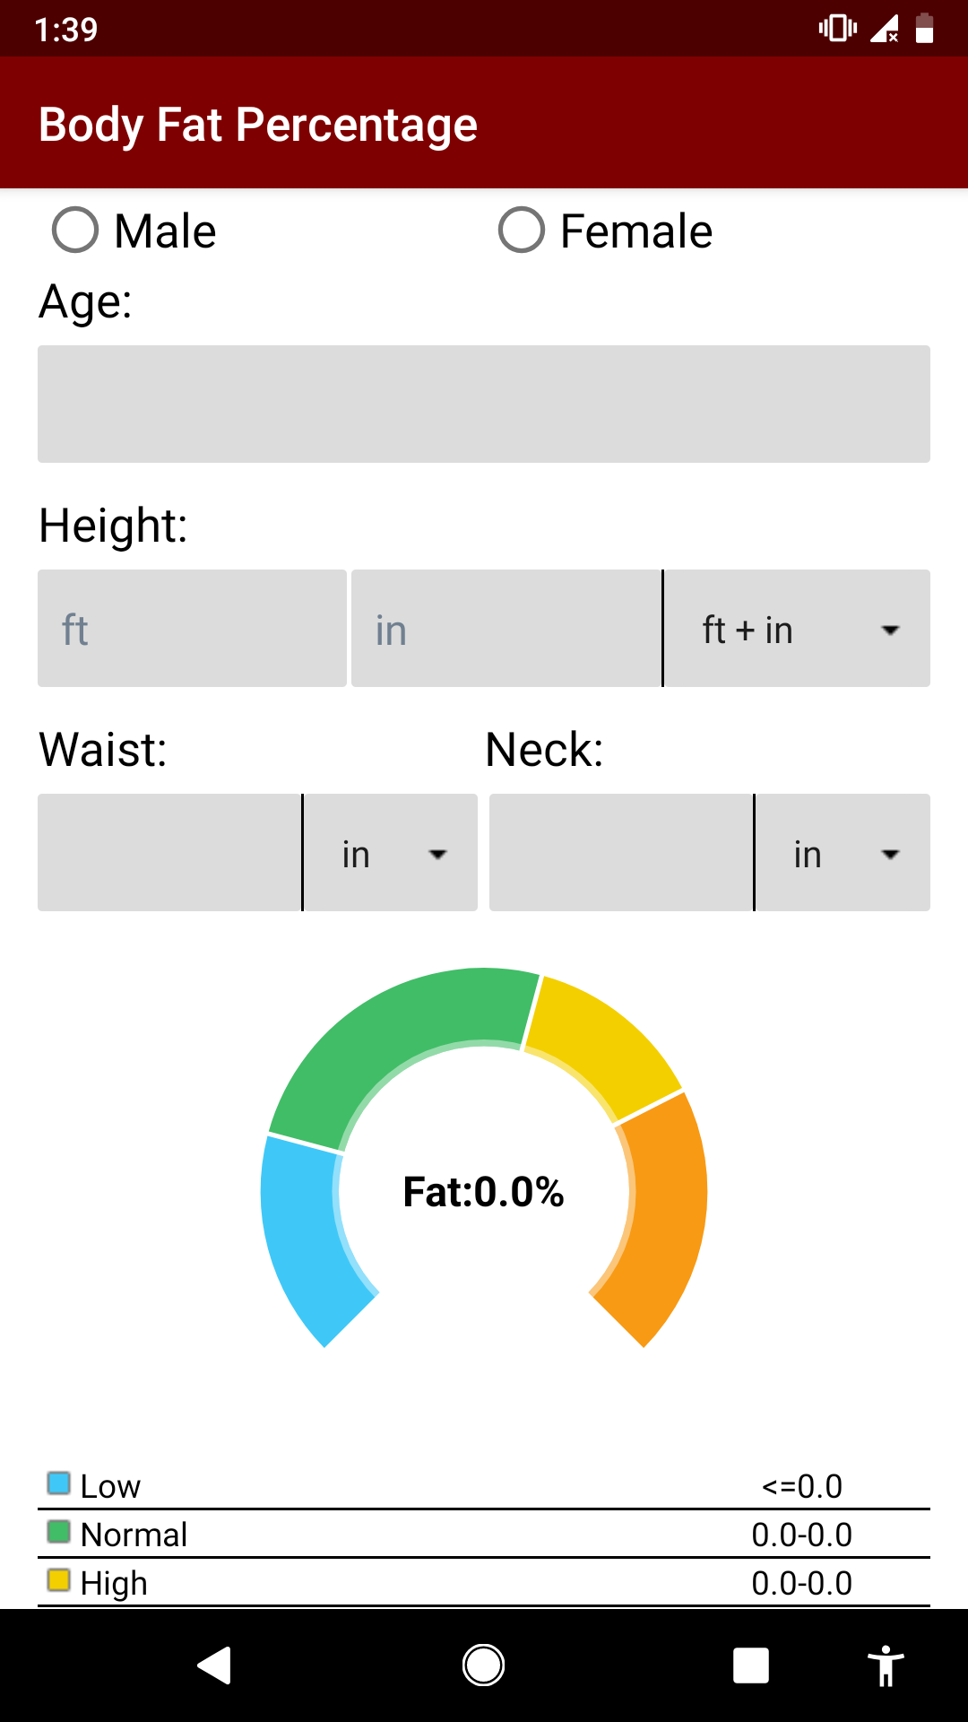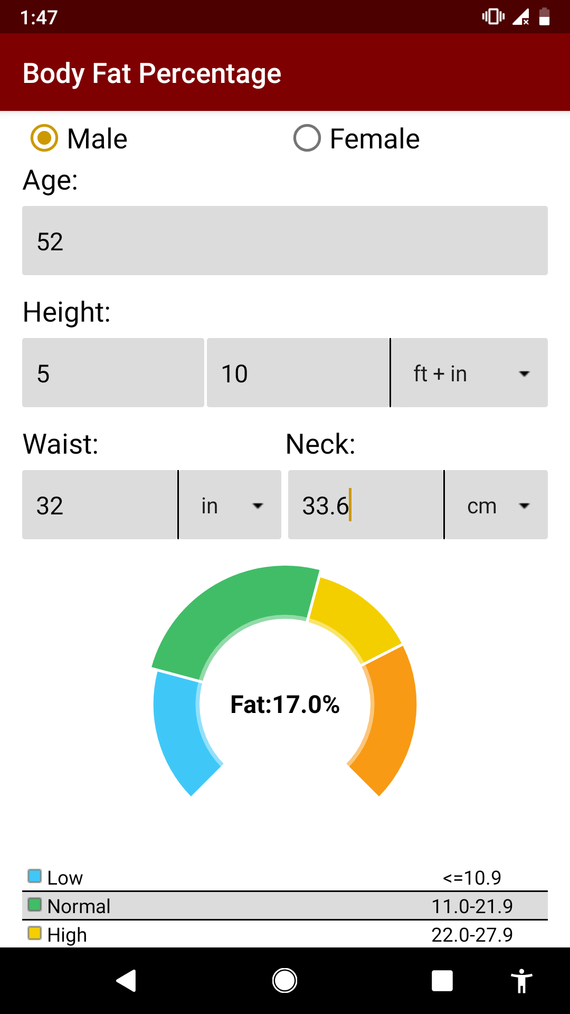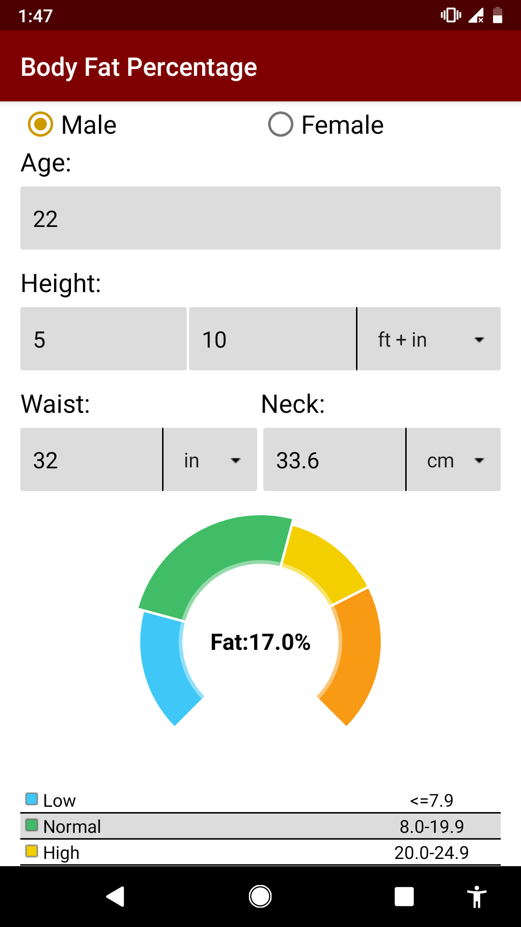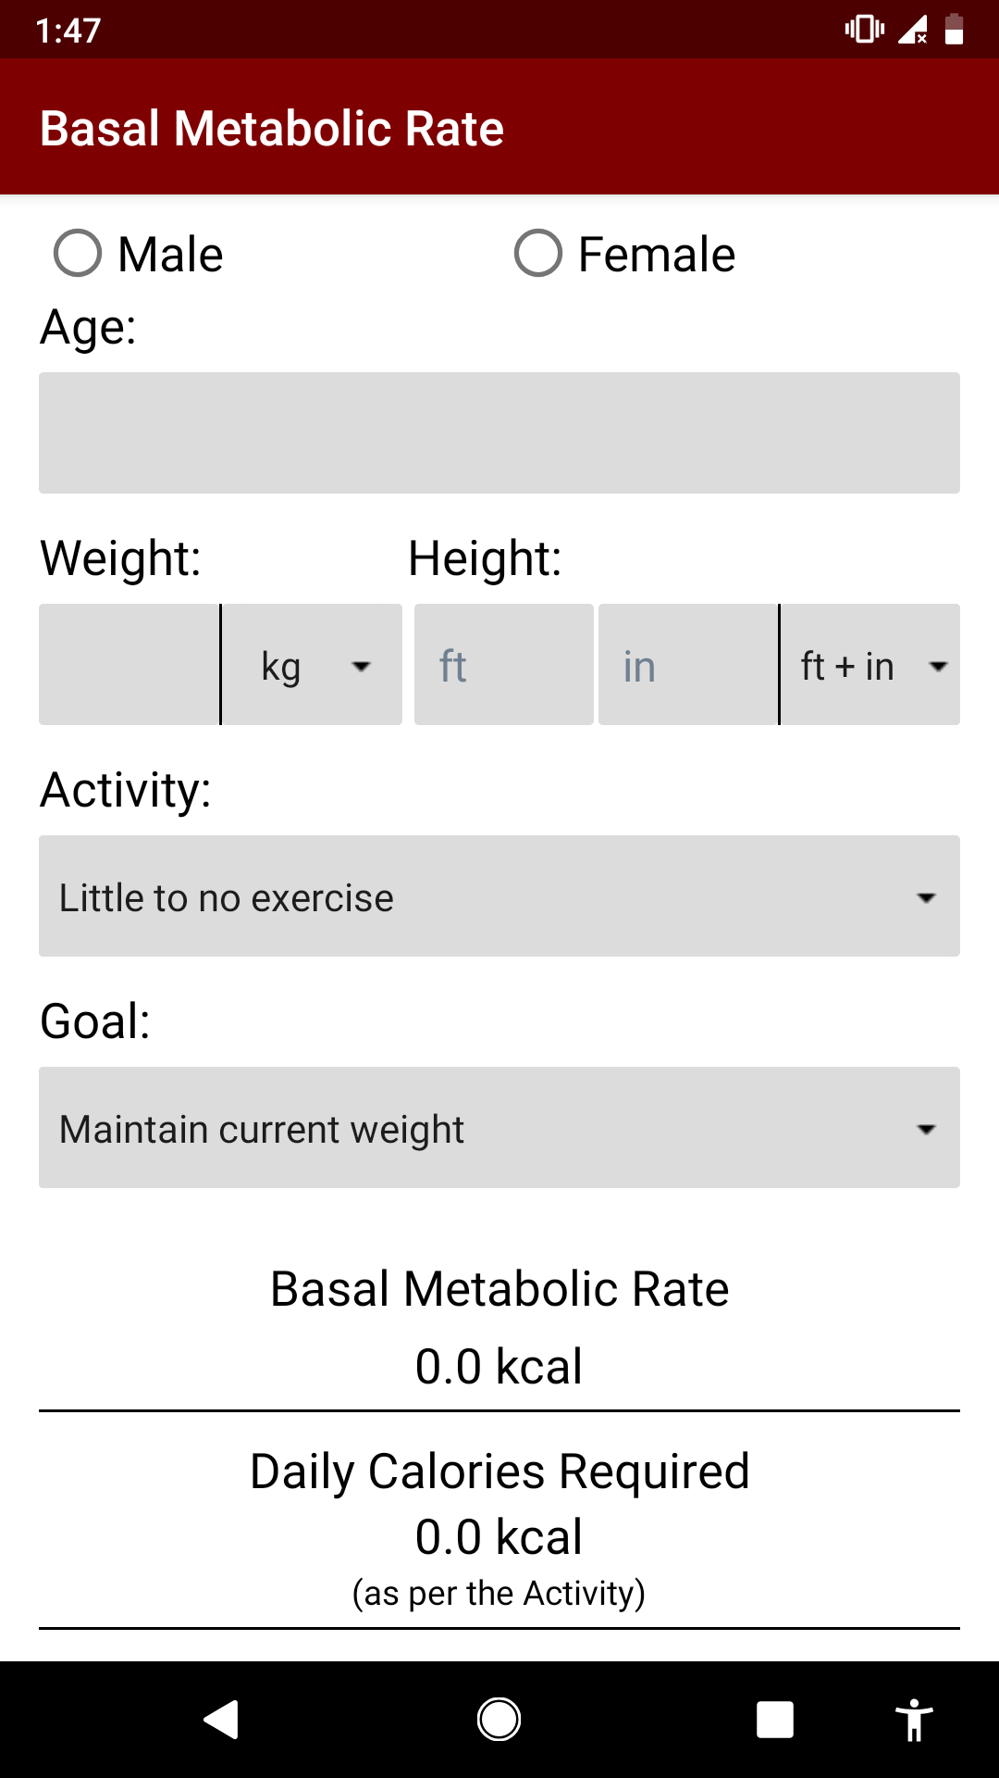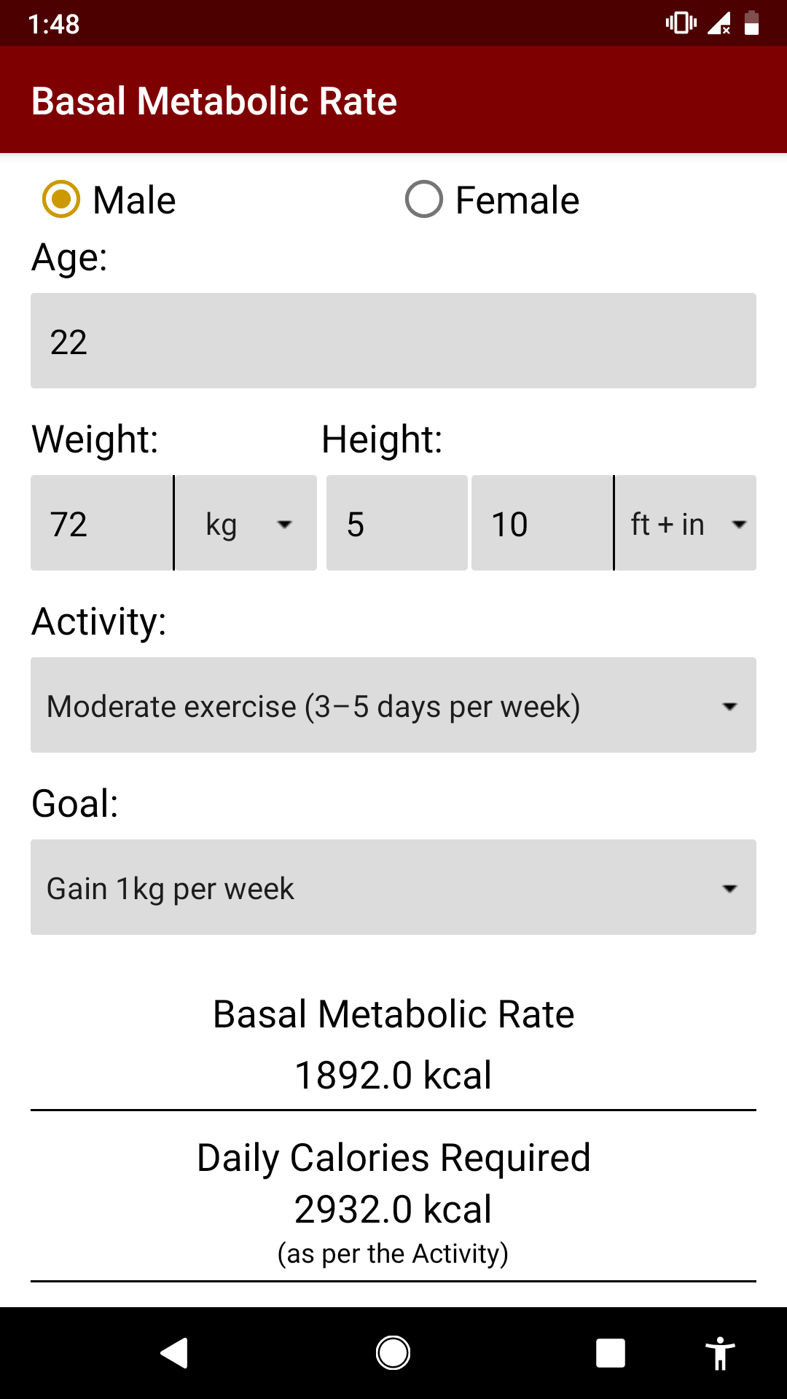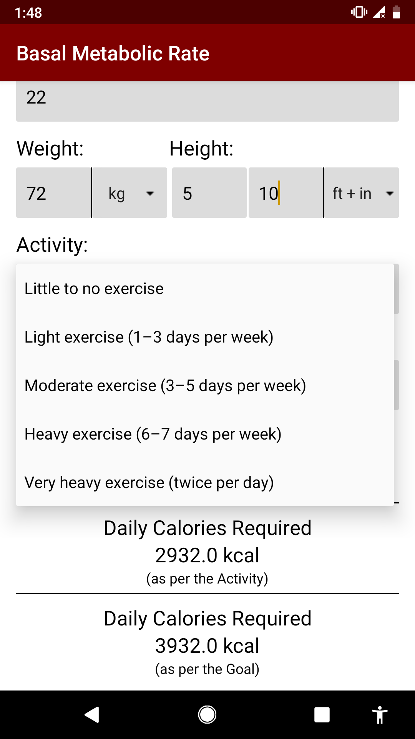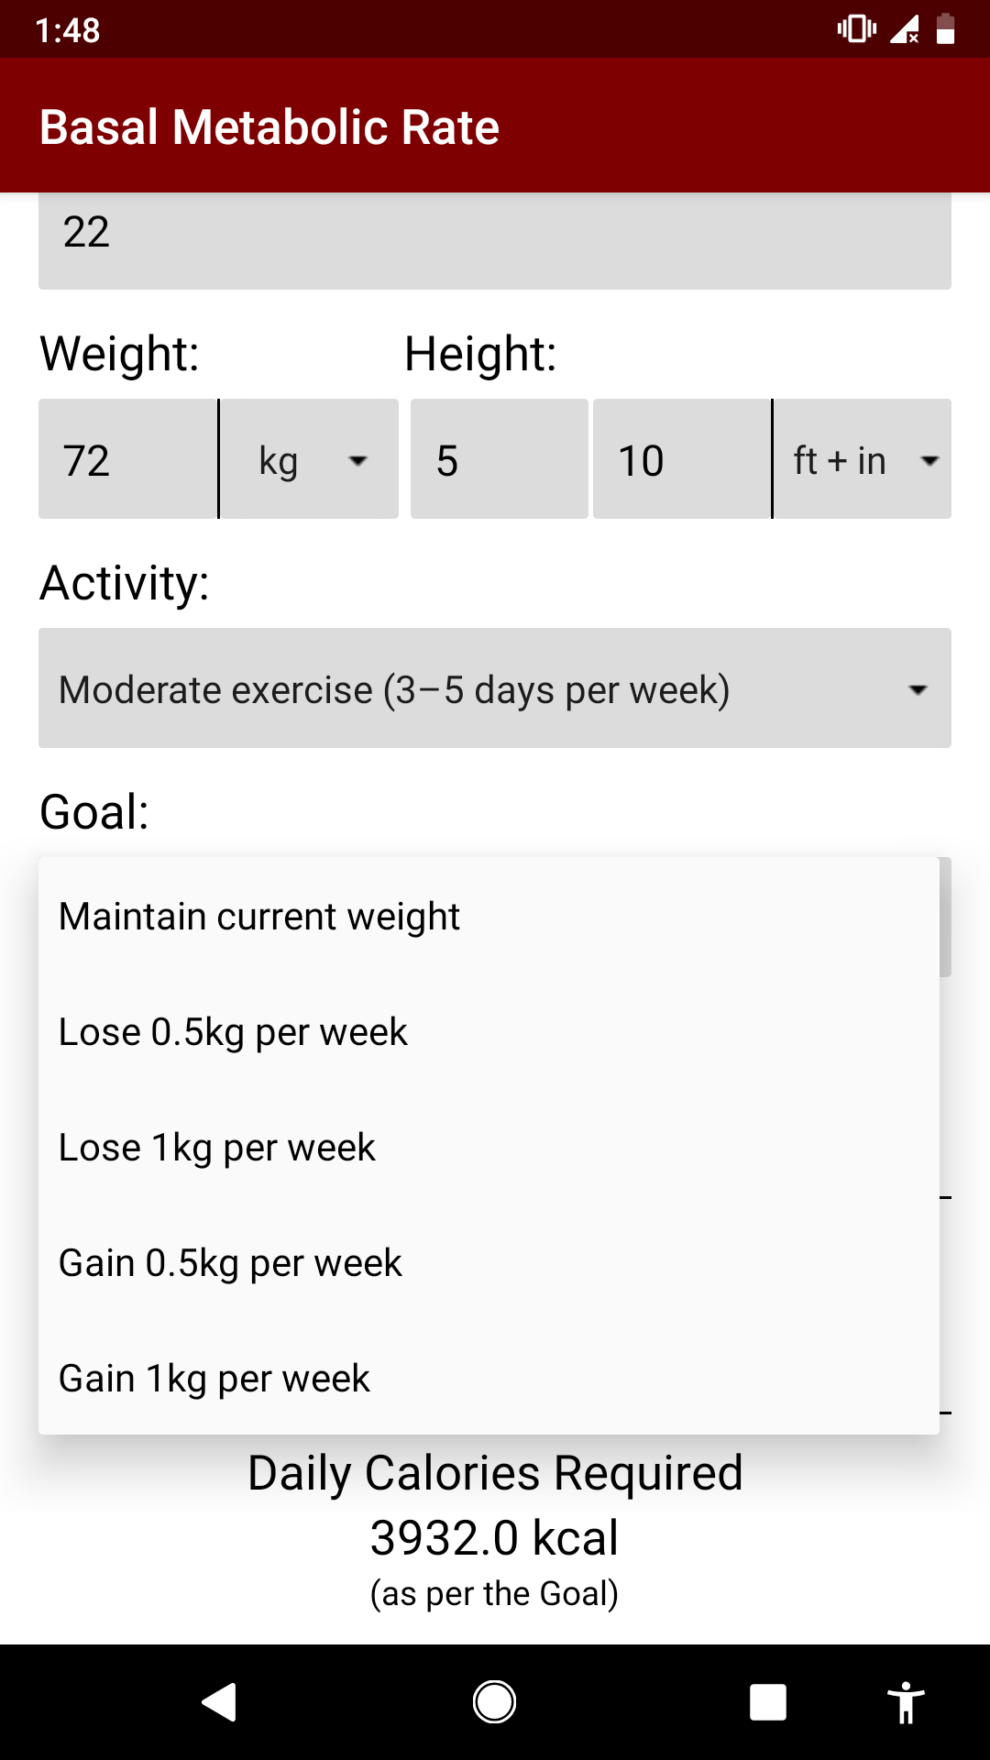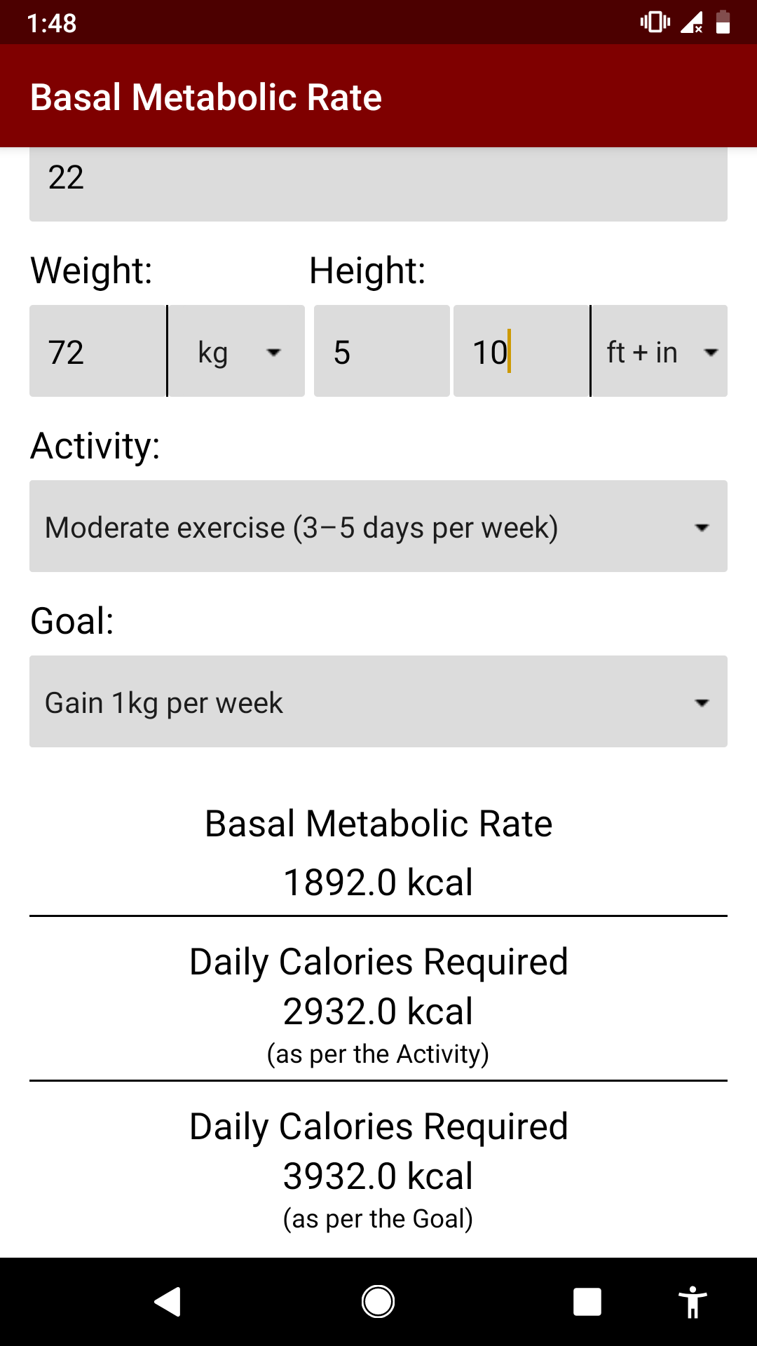

**CONCLUSION**

Thus we have implemented an DIET APP based on ANDROID . The app will give more accurate results as it accepts the data entered by the user and processes it depending on some metrics already known to the application on the basis of which a diet plan is generated and ask the user if the user accepts the diet plan. If not accepted the system may also give and alternative diet plan. Just similar to a human dietician, this system based on android operating system will also act like your device dietician. When you go to a doctor of nutrition, than she will ask you your personal details related to body and health such as your age, your height, your weight and how much water do you consumer in a day and how much walk to do take regularly and how much work do you do regularly. We have implemented an app which will also advice you about what should you intake in your diet and what should you ignore in order to keep yourself healthy via your diet.